UNITED STATES

SECURITIES AND EXCHANGE COMMISSION

WASHINGTON, DC 20549

FORM 8-K

CURRENT REPORT

PURSUANT TO SECTION 13 OR 15(d) OF THE
SECURITIES EXCHANGE ACT OF 1934

Date of report (Date of earliest event reported): September 25, 2003

SILICON LABORATORIES INC.

(Exact Name of Registrant as Specified in Charter)

Delaware

(State or Other Jurisdiction

of Incorporation)

000-29823

(Commission File Number)

74-2793174

(IRS Employer

Identification No.)

4635 Boston Lane, Austin, TX 78735

(Address of Principal Executive Offices) (Zip Code)

Registrant’s telephone number, including area code: (512) 416-8500

Not Applicable

(Former Name or Former Address, if Changed since Last Report)

Item 2. Acquisition and Disposition of Assets.

On September 25, 2003, Silicon Laboratories Inc., a Delaware corporation, Homestead Enterprises, Inc., a Delaware corporation and our wholly-owned subsidiary, and Cygnal Integrated Products, Inc., a Delaware corporation (“Cygnal”), entered into an Agreement and Plan of Reorganization pursuant to which we agreed to acquire Cygnal. Cygnal develops and sells analog-intensive, highly-integrated 8-bit microcontrollers. Under the terms of the Agreement and Plan of Reorganization, we will issue 1,191,658 shares of common stock in exchange for all of the outstanding capital stock of Cygnal at closing. We also have agreed to issue up to an additional 1,290,963 shares of our common stock to shareholders of Cygnal based on the achievement of certain revenue milestones during the twelve-month period commencing on April 4, 2004 and ending on April 2, 2005. The additional shares will become issuable as follows: (1) up to 297,915 shares on a pro rata basis for every dollar of Cygnal product revenues during the period in excess of $10.0 million up to $15.0 million; plus (2) up to 496,524 shares on a pro rata basis for every dollar of Cygnal product revenues during the period in excess of $15.0 million up to $20.0 million; plus (3) up to 496,524 shares on a pro rata basis for every dollar of Cygnal product revenues during the period in excess of $20.0 million up to $24.0 million.

This acquisition is subject to customary closing conditions, including regulatory approvals with respect to the issuance of our shares and the approval of Cygnal’s shareholders.

The press release announcing the acquisition is attached as Exhibit 99.1 to this Current Report on Form 8-K.

Item 7. Financial Statements and Exhibits.

(a)–(b) Financial Statements and Pro Forma Financial Information – None.

Silicon Laboratories Inc. will file the required financial statements and pro forma financial information related to the acquisition of Cygnal Integrated Products, Inc. within 60 days from the date of this filing.

- Exhibits.

99.1 Press release of Silicon Laboratories Inc. dated September 25, 2003 entitled “Silicon Laboratories To Acquire Cygnal Integrated Products, An Innovator In Mixed-Signal Microcontrollers.”

99.2 Conference call script for the September 25, 2003 conference call by Silicon Laboratories Inc. announcing the acquisition of Cygnal Integrated Products, Inc.

99.3 Presentation to be broadcast during the September 25, 2003 conference call by Silicon Laboratories Inc. announcing the acquisition of Cygnal Integrated Products, Inc.

2

Item 9. Regulation FD Disclosure.

On September 25, 2003, Silicon Laboratories Inc. issued a press release entitled “Silicon Laboratories Inc. To Acquire Cygnal Integrated Products, An Innovator In Mixed-Signal Microcontrollers.” The press release is attached as Exhibit 99.1 to this Current Report on Form 8-K.

Silicon Laboratories Inc. will be hosting a conference call on September 25, 2003 to announce the acquisition of Cygnal Integrated Products, Inc. A copy of the conference call script and presentation are attached as Exhibits 99.2 and 99.3, respectively, to this Current Report on Form 8-K for purposes of simultaneous disclosure under Rule 100 of Regulation FD.

The information in Item 9 of this Report (and the related exhibits filed herewith) shall not be deemed “filed” for purposes of Section 18 of the Securities Exchange Act of 1934, as amended. Unless expressly incorporated into a filing of the Registrant under the Securities Act of 1933, as amended, or the Securities Exchange Act of 1934, as amended, made after the date hereof, the information contained in Item 9 herein shall not be incorporated by reference into any filing of the Registrant, whether made before or after the date hereof, regardless of any general incorporation language in such filing.

3

SIGNATURE

Pursuant to the requirements of the Securities Exchange Act of 1934, the Registrant has duly caused this report to be signed on its behalf by the undersigned hereunto duly authorized.

Silicon Laboratories Inc.,

a Delaware corporation

Dated: September 25, 2003 By: /s/ Navdeep S. Sooch Navdeep S. Sooch

CHIEF EXECUTIVE OFFICER AND

CHAIRMAN OF THE BOARD

(PRINCIPAL EXECUTIVE OFFICER)

 | 4
 |  | SILICON LABORATORIES INC.
 |  | INDEX TO EXHIBITS
Exhibit |  | Description
Number |  | Description
99.1 | Press release of Silicon Laboratories Inc. dated September 25, 2003 entitled “Silicon Laboratories To Acquire Cygnal Integrated Products,
 | An Innovator In Mixed-Signal Microcontrollers.”
99.2 | Conference call script for the September 25, 2003 conference call by Silicon Laboratories Inc. announcing the acquisition of Cygnal
 | Integrated Products, Inc.
99.3 | Presentation to be broadcast during the September 25, 2003 conference call by Silicon Laboratories Inc. announcing the acquisition of
 | Cygnal Integrated Products, Inc.
 | 5

Exhibit 99.1


NEWS RELEASE

SILICON LABORATORIES TO ACQUIRE CYGNAL INTEGRATED

PRODUCTS, AN INNOVATOR IN MIXED-SIGNAL MICROCONTROLLERS

— Acquisition Marks Entry into Multi-billion Dollar General-Purpose Analog and MCU

Markets —

AUSTIN, Texas, Sept. 25, 2003 — Silicon Laboratories Inc. (Nasdaq: SLAB) today announced it has signed a definitive agreement to acquire Austin-based Cygnal Integrated Products, Inc., an innovator in analog-intensive, highly integrated 8-bit microcontrollers (MCUs). Cygnal’s portfolio of over 50 general-purpose products will add breadth and diversity to Silicon Laboratories’ existing product line of high-performance, application-specific mixed-signal ICs.

In connection with the acquisition, Silicon Laboratories will issue at closing approximately 1.2 million shares of common stock in exchange for all outstanding shares of Cygnal capital stock. Up to approximately 1.3 million additional shares of Silicon Laboratories common stock will be reserved for future issuance to the shareholders of Cygnal based on the achievement of certain revenue milestones following the closing of the transaction.

Cygnal’s C8051F family of microcontrollers is positioned at the intersection of the 8-bit MCU and the high-performance analog markets, which are estimated by Gartner to be $5 billion and $9 billion markets respectively. The Cygnal solution uniquely integrates intelligent data capture in the form of high-resolution data converters, a traditional MCU computing function, Flash memory and a highly programmable set of communication interfaces in a single system on a chip. The combination of configurable high-performance analog, 100 MIPS 8051 core and in-system field programmability provides the user with complete design flexibility, improved time-to-market, superior system performance and greater end product differentiation. This intersection is expected to become a sweet spot in large markets spanning consumer products and appliances, automotive, industrial systems, medical and networking applications.

“The acquisition of Cygnal reflects our strategy to further diversify our business and enhances our substantial development efforts underway on new products,” said Nav Sooch, chairman and chief executive officer of Silicon Laboratories. “Cygnal’s unique, analog-intensive approach delivers a highly differentiated product family that addresses the broad-based, high-margin, 8-bit MCU and general-purpose analog markets.”

“We have experienced strong initial acceptance of our products, shipping over 13,000 development systems and building a base of over 3000 customers,” said Derrell Coker, president and chief executive officer of Cygnal Integrated Products. “Silicon Laboratories’ well developed marketing capabilities, sales channel and market position offer an exciting means to gain increased share among the global customer base.”

“Cygnal is a clear match for Silicon Laboratories in terms of products, culture and engineering focus, making it a unique case where acquisition made sense within our strategic objectives,” said Dan Artusi, president and chief operating officer. “We believe that Silicon Laboratories’ strong global market presence will result in broader acceptance of Cygnal’s compelling product portfolio.”

The acquisition is expected to be slightly dilutive to Silicon Laboratories in 2004, becoming accretive during 2005. The acquisition is expected to close during the fourth quarter. The boards of directors of both companies have approved the merger, which awaits the satisfaction of regulatory requirements, approval by Cygnal’s shareholders and other customary closing conditions.

Conference Call Today

A conference call and presentation is scheduled for 4:15 p.m. Central Time. To access the presentation and audio webcast visit Silicon Laboratories’ website under Investor Relations http://www.silabs.com. A replay will be available after the call at the website listed above or by calling 800-945-8355 (U.S.) or 402-220-3594 (international). These replays will be available through October 25, 2003.

2

About Cygnal Integrated Products, Inc.

Cygnal, a private fabless semiconductor company based in Austin, Texas, was founded in 1999 and has 62 employees. Cygnal has 35 patents pending or issued on its family of analog-intensive, high-speed 8-bit MCUs that serve a broad range of markets and customers. Cygnal raised approximately $36 million in venture capital funding from Alliance Technology Ventures, Austin Ventures, Bank of America Venture Partners (BAVP) and other venture and private investors. For more information about Cygnal, please visit www.cygnal.com.

About Silicon Laboratories Inc.

Silicon Laboratories Inc. is a leading designer of high-performance, analog-intensive mixed-signal integrated circuits (ICs) for a broad range of applications. Silicon Laboratories’ diverse portfolio of highly integrated, patented solutions is developed by a world-class engineering team with decades of cumulative expertise in cutting-edge mixed-signal design. The company has design, engineering, marketing, sales and applications offices throughout North America, Europe and Asia. For more information about Silicon Laboratories please visit www.silabs.com.

Where to Find Additional Information

Silicon Laboratories intends to seek approval of the California Corporations Commission or, in the alternative, file a registration statement, including proxy statement/prospectus and other relevant materials with the SEC, for the issuance of its shares in connection with the proposed acquisition of Cygnal by Silicon Laboratories. The informational materials or, if applicable, proxy statement/prospectus, will be mailed to the stockholders of Cygnal. Stockholders of Cygnal and investors are urged to read the relevant materials when they become available before making any voting or investment decision with respect to the

proposed merger, because they will contain important information about Silicon Laboratories, Cygnal and the proposed merger. In addition, Silicon Laboratories files annual, quarterly and special reports, proxy statements and other information with the SEC, which may be obtained free of charge at the SEC’s web site at www.sec.gov. In addition, stockholders and investors may obtain free copies of the documents filed with the SEC by Silicon Laboratories by contacting Silicon Laboratories Investor Relations, 4635 Boston Lane, Austin, Texas 78735, (512) 416-8500.

Cautionary Language

This press release contains forward-looking statements based on Silicon Laboratories’ current expectations. The words “believe,” “expect,” “intend,” “plan,” “project,” “will” and similar phrases as they relate to Silicon Laboratories are intended to identify such forward-looking statements. These forward-looking statements reflect the current views and assumptions of Silicon Laboratories and are subject to various risks and uncertainties that could cause actual results to differ materially from expectations. Among the risks or factors that could cause actual results to differ materially from those in the forward-looking statements are as follows: risks associated with the completion of the Cygnal acquisition; the impact that failure to do so could have on the realization of the anticipated benefits of the acquisition; risks associated with the successful integration of Cygnal’s business or the failure to do so in a manner that realizes the anticipated benefits of the acquisition; that Silicon Laboratories may not be able to maintain its historical growth rate; quarterly fluctuations in revenues and operating results; risks that Silicon Labs may not be able to manage strains associated with its growth; dependence on new product development; rapid technological and market change; difficulties developing new products that

3

achieve market acceptance; difficulties managing international activities; credit risks associated with our accounts receivable; geographic concentration of manufacturers, assemblers, test service providers and customers in the Pacific Rim that subjects Silicon Laboratories’ business and results of operations to risks of natural disasters, epidemics, war and political unrest; dependence on a limited number of products and customers; product development liability risks; intellectual property litigation risks; acquisition strategy; the competitive and cyclical nature of the semiconductor industry and other factors that are detailed in Silicon Laboratories filings with the SEC, including the Form 10-K filed January 22, 2003 and the Form 10-Q filed July 21, 2003.

Note to editors: Silicon Laboratories and the Silicon Laboratories logo are trademarks of Silicon Laboratories Inc. All other product names noted herein may be trademarks of their respective holders.

CONTACT: Silicon Laboratories Inc., Shannon Pleasant, 512/464-9254 investor.relations@silabs.com

# # #

4

Exhibit 99.2

Expanding Market Leadership

Silicon Laboratories Investor Conference Call

Shannon:

(Slide 1)

Good Afternoon. This is Shannon Pleasant, director of corporate communications for Silicon Laboratories. Thank you for joining us today to discuss the company’s announcement of a definitive agreement to acquire Cygnal Integrated Products, Inc. The presentation for today’s call as well as the press release and filings associated with the transaction are available on the investor page of our website at www.silabs.com.

This call and presentation is being simulcast and will be archived on our website. There will also be a telephone replay available approximately one hour after the completion of the call at 800-945-8355 until October 25th.

I am joined today by Nav Sooch, chairman and CEO, Dan Artusi, president and chief operating officer, and John McGovern, interim chief financial officer. John will summarize the definitive agreement, and Nav and Dan will discuss the strategy and business implications of the acquisition. We will have a question and answer session following the presentation.

Silicon Laboratories intends to seek approval of the California Corporations Commission or, in the alternative, file a registration statement, including proxy statement/prospectus and other relevant materials with the SEC, for the issuance of its shares in connection with the proposed acquisition of Cygnal by Silicon Laboratories. The informational materials will be mailed to the stockholders of Cygnal. Stockholders of Cygnal and investors are urged to read the relevant materials when they become available before making any voting or investment decision with respect to the proposed merger, because they will contain important information about Silicon Laboratories, Cygnal and the proposed merger. In addition, stockholders and investors may obtain free copies of the documents filed with the SEC by Silicon Laboratories by contacting Silicon Laboratories Investor Relations or be visiting www.sec.gov.

(Slide 2)

Let me comment regarding the Safe Harbor Statement under the Private Securities Litigation Reform Act of 1995. Our comments and presentation today will include forward-looking statements or projections that involve substantial risks and uncertainties. We base these forward-looking statements on information available to us as of the date of this conference call. This

1

information will likely change over time. By discussing our current perception of our market and the future performance of Silicon Laboratories and our products with you today, we are not undertaking an obligation to provide updates in the future. There are a variety of factors that we may not be able to accurately predict or control that could have a material adverse effect on our business, operating results and financial condition. We encourage you to review our SEC filings that identify important factors that could cause actual results to differ materially from those contained in any forward-looking statements.

And now I would like to introduce Silicon Laboratories’ CFO, John McGovern.

(Slide 3)

John:

Thanks Shannon.

Today we signed a definitive agreement to acquire Cygnal Integrated Products for approximately 1.2 million shares of common stock totaling $60 million dollars in value. Based on Cygnal’s ability to meet revenue related milestones beginning in the second quarter of 2004 through Q1 of 2005, there is an additional maximum $65 million pay out distributed in stock. We believe the acquisition will become accretive during 2005. The transaction is expected to close late in the fourth quarter of 2003.

Nav will now discuss the business drivers behind the acquisition, Nav –

Nav:

Thanks John.

We are very excited about the acquisition of Cygnal. As you know, acquisition has not been a main part of our strategy in the past because we set a very high bar for evaluating potential acquisition candidates. Cygnal uniquely met all of our criteria, providing us with a very synergistic product line.

2

(Slide 4)

Cygnal’s strategy is well aligned with our corporate objectives. First, it presents us with a large and attractive market opportunity. The Cygnal product line addresses a broad base of customers and market segments, which is consistent with Silicon Labs’ diversification strategy.

Second, these are high margin, analog intensive, mixed-signal products that are clearly differentiated and they do not overlap with our existing products. Our combined expertise also creates some very interesting joint development possibilities.

Third, we expect the integration to be seamless and straightforward. Cygnal is based in Austin. Many of the Silicon Labs employees worked with members of the Cygnal team at prior companies, so they’re a known quantity, and there is a high degree of mutual respect. Their offices are 10 minutes away and we

expect to relocate the entire team to our location. Cygnal also has a supply chain that’s virtually identical to ours.

(Slide 5)

This is a chart most of you are familiar with; it speaks to our corporate strategy. We’ve always felt our strength is in our world-class engineering talent. Building on this foundation, our product selection is based on meeting the criteria in this strategic filter. Everything we’ve developed has been based on a first-of-a-kind approach to solving difficult engineering problems. This approach allows us to innovate and create high gross margin, long-life cycle products with strong IP portfolios.

By consistently applying this strategic filter, we expect to achieve diversity in products, markets and customers.

(Build 1)

I’d like to review how Cygnal’s product line clearly aligns with Silicon Labs’ strategy.

3

Their engineering team is very experienced. I’ve worked with many of them at a prior company and have first hand knowledge of this high-caliber team.

They have taken a unique approach that combines high-performance analog with a high performance MCU to create differentiated products with margins comfortably above our corporate average.

Lastly, Cygnal addresses the intersection between the $5 billion dollar 8-bit MCU market and the $9 billion dollar high-performance analog market, which is obviously very broad with tens of thousands of prospective customers. This is directly in line with our desire to further diversify our customer base.

Now I’m going to turn the call over to Dan to talk about Cygnal’s products and markets.

Dan –

(Slide 6)

Dan:

Thank you Nav.

Cygnal is based here in our hometown, Austin, TX. Founded in 1999, Cygnal is privately held and reported $5.2 million in revenue in 2002. Cygnal has a broad family of highly integrated, mixed-signal 8-bit microcontrollers. Cygnal has already shipped over 13,000 development kits and grown their customer base to over 3000 customers. This clearly demonstrates early customer acceptance of their products. Cygnal’s portfolio of over 50 devices is supported by world-class development tools, including their own IDE and strong third-party support. (Slide 7)

4

Cygnal’s microcontroller family is focused on the 8-bit MCU market and is based on the 8051 architecture. If we look at the product’s value proposition, you will see a lot of similarities to Silicon Laboratories’ product benefits: an analog intensive, highly integrated part that simplifies the customers design effort and dramatically reduces the bill of materials.

I’d like to give you some perspective on the market. Literally millions of electronic systems have analog sensors where signals are converted to digital, processed by a microcontroller and then communicated in some manner to the system. Cygnal’s unique approach takes all of these functions and integrates them into a single chip. The benefits of this approach are improved performance, less board real estate and lower system cost.

In the comparison on this slide, you can see that a typical data acquisition solution requires seven to ten times the number of devices to implement a relatively low performance MCU with stand alone analog-to-digital and digital-to-analog conversion.

Cygnal’s solution integrates all of these functions along with Flash memory to build a complete system on a chip. This solution enables full, in-system field programmability, high-performance MCU and complete integration of the analog blocks in an elegant mixed-signal design. (Slide 8)

This approach to mixed-signal MCU design has resulted in a very competitive portfolio of products when benchmarked against the competition. I’d like to point out a few major advantages of Cygnal’s product family. Their broad portfolio of MCU products is on par with the established players in the market. In addition, the C8051F MCUs have clear advantages in CPU throughput from 20-100 MIPS, and substantially higher functionality than the competition in data conversion and performance. The C8051F family also employs a unique I/O strategy. Cygnal came up with a novel solution to the problem of

5

allocating pins to general or special-purpose I/O in the form of a programmable crossbar switch.

(Slide 9)

The 8-bit MCU market has been growing for the last 25 years because MCUs have become more and more pervasive in a variety of applications. For example, 8-bit MCU products are routinely found in the industrial, automotive, consumer and communications markets.

(Slide 10)

Cygnal’s strategy leverages the increasing integration driving the intersection between the 8-bit MCU and the high-performance analog markets. Cygnal was the first to build a product for this large and growing opportunity and is still the only company with optimized products to take advantage of this market intersection. This intersection exists in all of the markets I just mentioned, including industrial, automotive, consumer and communications.

As many of you know, Silicon Labs has clearly demonstrated the ability to quickly establish significant share in large vertical markets. We believe we can leverage Cygnal’s unique position to capture a large share of these markets.

(Slide 11)

Cygnal has established initial acceptance across several markets as a result of early execution and innovative design. We believe that the combination of our global sales organization, market position and acceptance by large OEMs will broaden and accelerate design wins with Cygnal’s products.

(Slide 12)

Over the long-term, you can expect us to leverage a growing portfolio of both application specific and general-purpose products. These complementary product lines will offer synergies in terms of growth and life cycle, creating a very balanced business.

6

I’ll now turn the presentation back to Nav,

(Slide 13)

Nav:

Thanks Dan,

I’d like to take this opportunity to reinforce our corporate mission. Our goal is to be the leader in high-performance, analog-intensive, mixed-signal solutions. We believe this acquisition helps us to further this objective.

(Slide 14)

I’d also like to emphasize that we are focused on our internal growth objectives, independent of this acquisition. We continue to work on the largest development pipeline in the company’s history and progress on these projects is on track. This acquisition will add additional integration opportunities to our pipeline.

As we’ve discussed in the past, many of our new development projects are focused on new applications while others are focused on increasing dollar content

in existing markets where we compete today. We believe that the combination of these development efforts will result in significant and sustained long-term

revenue growth.

(Slide 15)

In summary, Cygnal represents a fantastic opportunity that will expand our market reach with a highly innovative, complementary, high gross margin product line. We know their team, and the company is based in Austin, so we expect the integration to go smoothly. Clearly, this acquisition is a great match, and we’re excited about the new doors it will open for Silicon Labs.

7

Shannon –

(Slide 16)

Shannon

Thank you, Nav. We expect to announce earnings on October 20th, so we would like to limit the questions today to topics related to the acquisition. Operator, please review the question and answer instructions for our call participants.

(AFTER QUESTIONS)

Thank you for participating in today’s call.

8



Link to searchable text of slide shown above
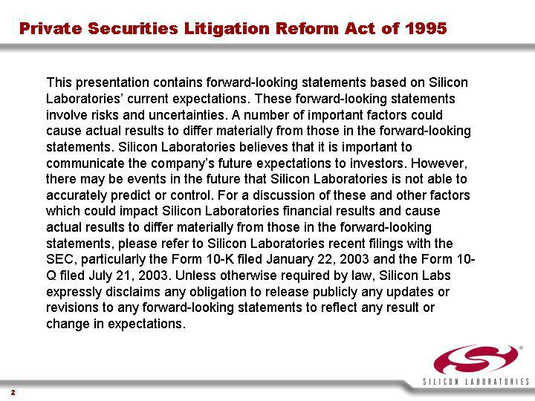

Link to searchable text of slide shown above

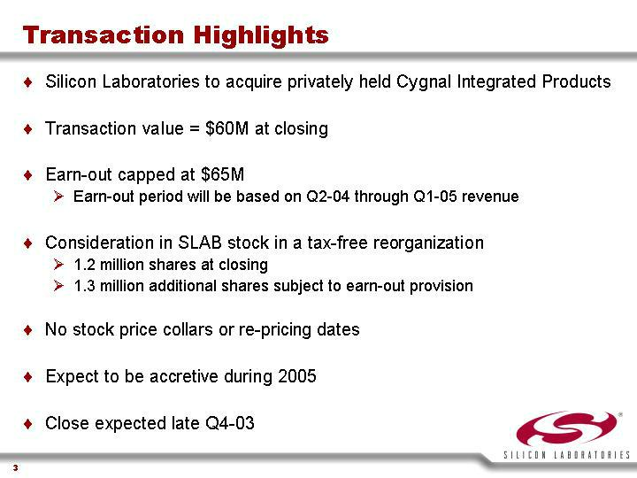

Link to searchable text of slide shown above
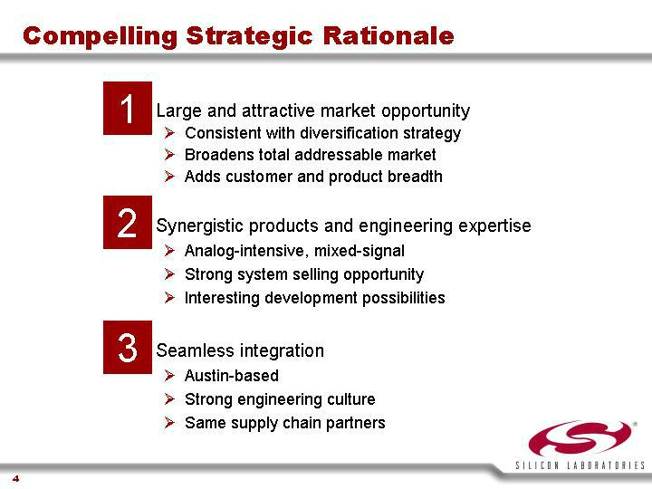

Link to searchable text of slide shown above

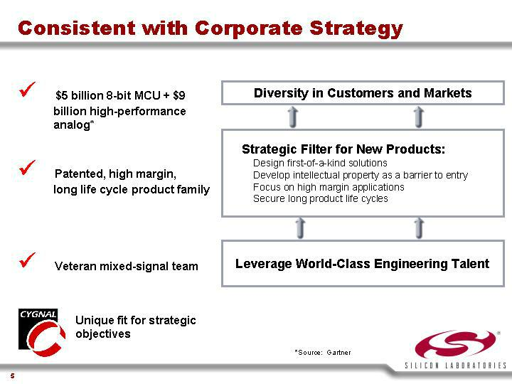

Link to searchable text of slide shown above
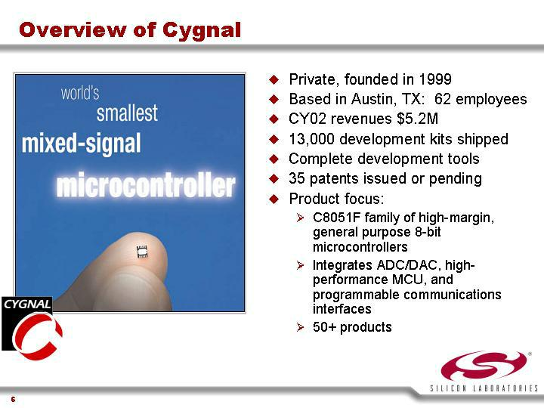

Link to searchable text of slide shown above
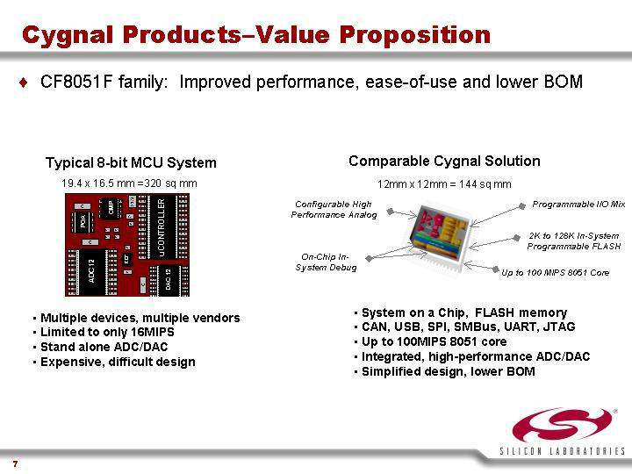

Link to searchable text of slide shown above

Link to searchable text of slide shown above
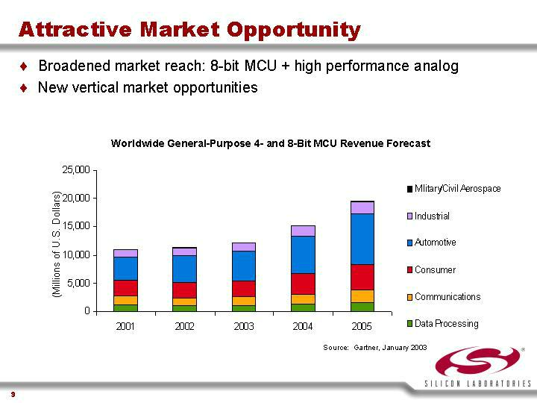

Link to searchable text of slide shown above
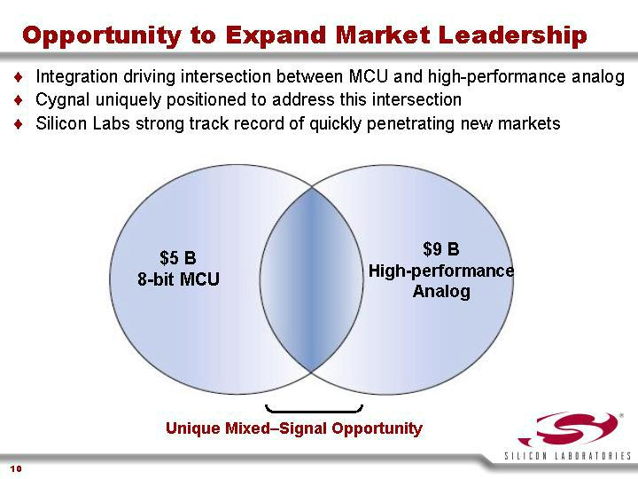

Link to searchable text of slide shown above
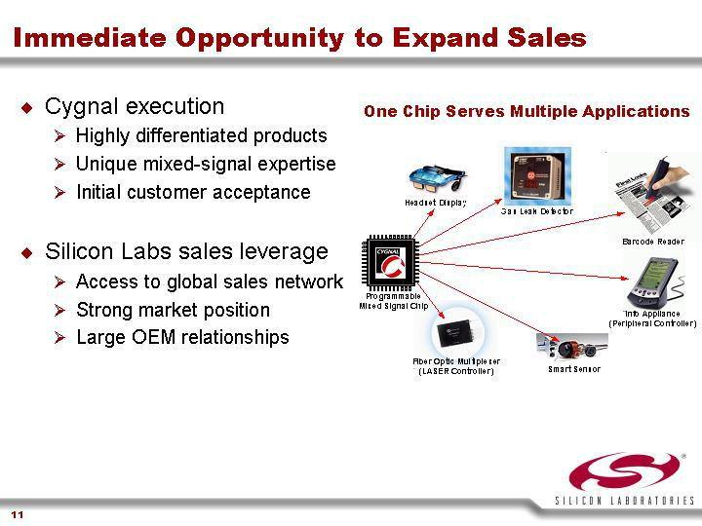

Link to searchable text of slide shown above

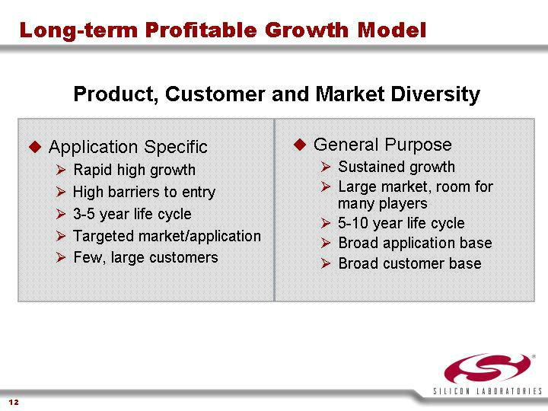

Link to searchable text of slide shown above
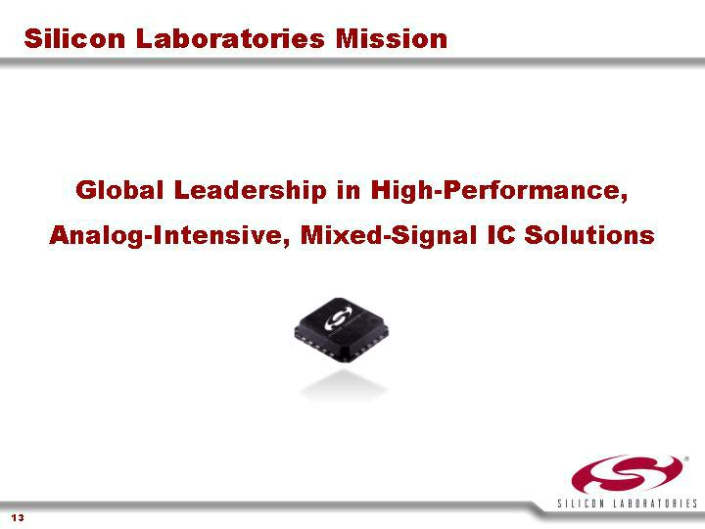

Link to searchable text of slide shown above

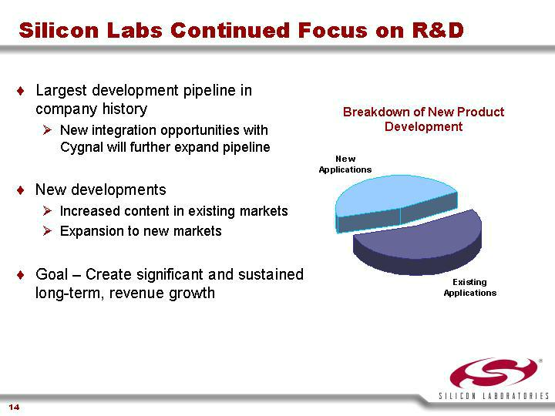

Link to searchable text of slide shown above
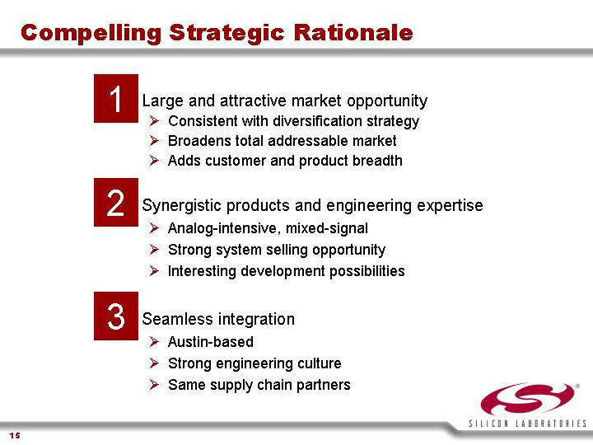

Link to searchable text of slide shown above



Link to searchable text of slide shown above

Searchable text section of graphics shown above

Exhibit 99.3

[LOGO]

SILICON LABORATORIES

[GRAPHIC]

Expanding Market Leadership

Private Securities Litigation Reform Act of 1995

This presentation contains forward-looking statements based on Silicon Laboratories’ current expectations. These forward-looking statements involve risks and uncertainties. A number of important factors could cause actual results to differ materially from those in the forward-looking statements. Silicon Laboratories believes that it is important to communicate the company’s future expectations to investors. However, there may be events in the future that Silicon Laboratories is not able to accurately predict or control. For a discussion of these and other factors which could impact Silicon Laboratories financial results and cause actual results to differ materially from those in the forward-looking statements, please refer to Silicon Laboratories recent filings with the SEC, particularly the Form 10-K filed January 22, 2003 and the Form 10-Q filed July 21, 2003. Unless otherwise required by law, Silicon Labs expressly disclaims any obligation to release publicly any updates or revisions to any forward-looking statements to reflect any result or change in expectations.

[LOGO]

Silicon Laboratories Confidential

2

Transaction Highlights

- Silicon Laboratories to acquire privately held Cygnal Integrated Products

- Transaction value = $60M at closing

- Earn-out capped at $65M

  - Earn-out period will be based on Q2-04 through Q1-05 revenue

- Consideration in SLAB stock in a tax-free reorganization

  - 1.2 million shares at closing

  - 1.3 million additional shares subject to earn-out provision

- No stock price collars or re-pricing dates

- Expect to be accretive during 2005

- Close expected late Q4-03

3

Compelling Strategic Rationale

- Large and attractive market opportunity

  - Consistent with diversification strategy

  - Broadens total addressable market

  - Adds customer and product breadth

- Synergistic products and engineering expertise

  - Analog-intensive, mixed-signal

  - Strong system selling opportunity

  - Interesting development possibilities

- Seamless integration

  - Austin-based

  - Strong engineering culture

  - Same supply chain partners

 |  | 4
Consistent with Corporate Strategy
• | $5 billion 8-bit MCU + $9 billion high-performance analog* | Diversity in Customers and Markets
• | Patented, high margin, long life cycle product family | Strategic Filter for New Products:
 |  | Design first-of-a-kind solutions
 |  | Develop intellectual property as a barrier to entry
 |  | Focus on high margin applications
 |  | Secure long product life cycles
• | Veteran mixed-signal team | Leverage World-Class Engineering Talent

[GRAPHIC]

Unique fit for strategic objectives

*Source: Gartner

5

Overview of Cygnal

world’s smallest mixed-signal microcontroller

[GRAPHIC]

- Private, founded in 1999

- Based in Austin, TX: 62 employees

- CY02 revenues $5.2M

- 13,000 development kits shipped

- Complete development tools

- 35 patents issued or pending

- Product focus:

  - C8051F family of high-margin, general purpose 8-bit microcontrollers

  - Integrates ADC/DAC, high-performance MCU, and programmable communications interfaces

  - 50+ products

6

Cygnal Products–Value Proposition

- CF8051F family: Improved performance, ease-of-use and lower BOM

Typical 8-bit MCU System

19.4 x 16.5 mm =320 sq mm

[GRAPHIC]

- Multiple devices, multiple vendors

- Limited to only 16MIPS

- Stand alone ADC/DAC

- Expensive, difficult design

Comparable Cygnal Solution

12mm x 12mm = 144 sq mm

[GRAPHIC]

- System on a Chip, FLASH memory

- CAN, USB, SPI, SMBus, UART, JTAG

- Up to 100MIPS 8051 core

- Integrated, high-performance ADC/DAC

- Simplified design, lower BOM

7

Cygnal–Differentiated Products

- Intelligent, mixed-signal 8051 architecture

- Industry leading performance

- Flexible, programmable

- Clear advantages in:

  - CPU throughput

  - A/D performance

  - D/A conversion

  - Serial connectivity

  - Size

Attribute |  | Cygnal |  | Competing
 |  | C8051F |  | Solutions
# FLASH MCUs |  | 52 |  | 45
CPU Throughput |  | 20 --> 100MIPS |  | 1 --> 16MIPS
A/D Converter |  | 8, 10, 12, 16-Bit |  | 8, 10-Bit
A/D Performance |  | ☒ |  | ☒
D/A Converter |  | 10-Bit, 12-Bit |  | NONE
 |  | UART, SPI, SMBus, |  | UART, SPI,
Serial Connectivity |  | USB2.0, CAN |  | SMBus, CAN
Low Power |  | ☒ |  | ☒
Smallest Package |  | 11-Pin |  | 8 to 20-Pin

9mm sq. 27-138 mm sq.

8

Attractive Market Opportunity

- Broadened market reach: 8-bit MCU + high performance analog

- New vertical market opportunities

Worldwide General-Purpose 4- and 8-Bit MCU Revenue Forecast

[CHART]

Source: Gartner, January 2003

9

Opportunity to Expand Market Leadership

- Integration driving intersection between MCU and high-performance analog

- Cygnal uniquely positioned to address this intersection

- Silicon Labs strong track record of quickly penetrating new markets

[CHART]

Unique Mixed–Signal Opportunity

10

Immediate Opportunity to Expand Sales

- Cygnal execution

  - Highly differentiated products

  - Unique mixed-signal expertise

  - Initial customer acceptance

- Silicon Labs sales leverage

  - Access to global sales network

  - Strong market position

  - Large OEM relationships

 |  | One Chip Serves Multiple Applications
 |  | [GRAPHIC]
 |  | 11
Long-term Profitable Growth Model
 |  | Product, Customer and Market Diversity
• Application Specific |  | • General Purpose
• | Rapid high growth | • | Sustained growth
• | High barriers to entry | • | Large market, room for many players
• | 3-5 year life cycle | • | 5-10 year life cycle
• | Targeted market/application | • | Broad application base
• | Few, large customers | • | Broad customer base
 |  | 12

Silicon Laboratories Mission

Global Leadership in High-Performance,

Analog-Intensive, Mixed-Signal IC Solutions

[GRAPHIC]

13

Silicon Labs Continued Focus on R&D

- Largest development pipeline in company history

  - New integration opportunities with Cygnal will further expand pipeline

- New developments

  - Increased content in existing markets

  - Expansion to new markets

- Goal – Create significant and sustained long-term, revenue growth

Breakdown of New Product

Development

[CHART]

14

Compelling Strategic Rationale

- Large and attractive market opportunity

  - Consistent with diversification strategy

  - Broadens total addressable market

  - Adds customer and product breadth

- Synergistic products and engineering expertise

  - Analog-intensive, mixed-signal

  - Strong system selling opportunity

  - Interesting development possibilities

- Seamless integration

  - Austin-based

  - Strong engineering culture

  - Same supply chain partners

15

[LOGO]

www.silabs.com

www.cygnal.com

